**Add Zero Production Count**

Taki Guan

# Version History

|  |  |  |  |
| --- | --- | --- | --- |
| Version | Author | Date | Changes |
| 1.0 | Taki Guan | 2019-4-1 | Create Document |
| 1.0 | Taki Guan | 2019-4-4 | Finish Document |
|  |  |  |  |
|  |  |  |  |
|  |  |  |  |
|  |  |  |  |

Contents

Version History 1

Purpose 1

Procedure 1

Architecture 3

Reference Link 6

# Purpose

This file is to describe how to add zero production count for specific line on specific shift.

This file will help other developers to find the store procedure and batch code generation logic.

# Procedure

This function will help if system issue happens and no work order record in that shift. If I get the line name, work order, date and shift then I can insert 0 records to [job] and [item_prod] table.

The operation sequence is as below:

1. Operator open admin window;
2. Click “Production Reconcile” button;
3. Click “Add Production” button;
4. Select line, work order, date and shift to submit record;
5. Select specific line and work order and refresh to check if 0 records exist.

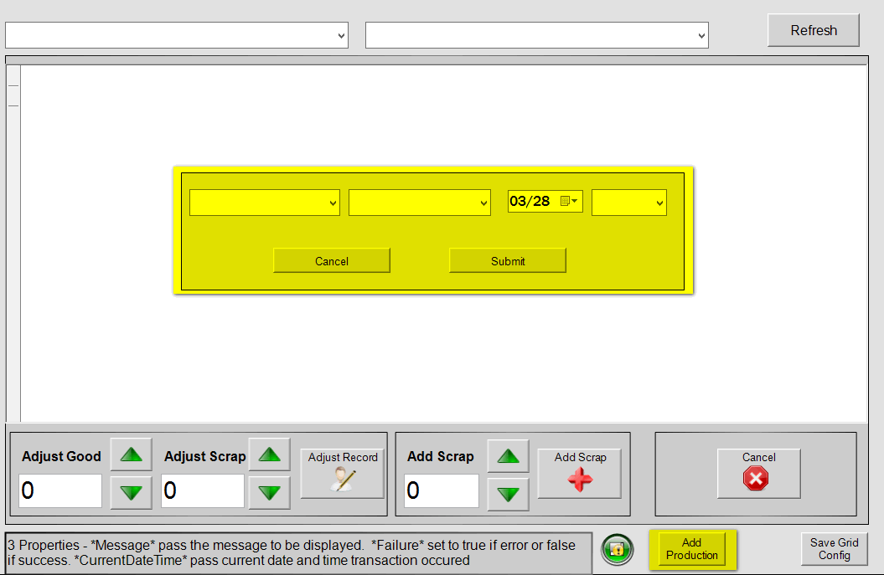

This graphic will appear after “Add Production” button clicked. Other graphic will be hided on background.

# Architecture

**[operaAdmin_ProductionRecon_SX]**

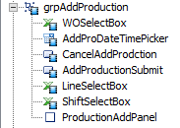

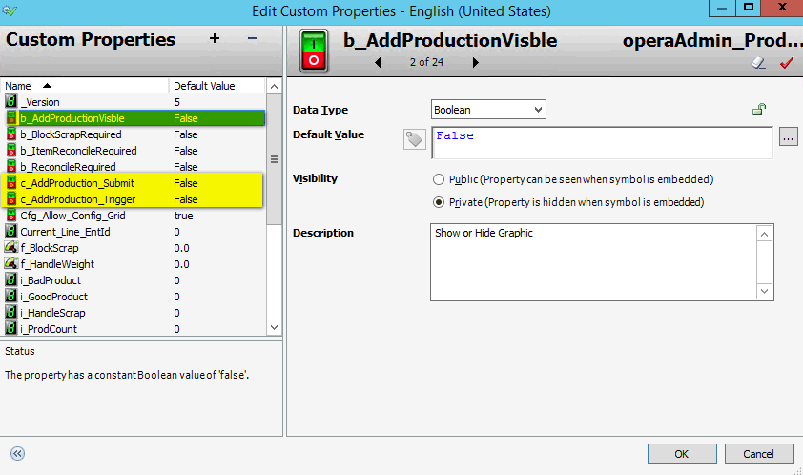

We need to create custom properties:

[b_AddProductionVisble]

Make the add production graphic visible.

[c_AddProduction_Trigger]

Initialize the add production graphic.

[c_AddProduction_Submit]

Submit and execute the store procedure.

After we create the graphic we need to design below logic to initialize the graphic.

I add one [Pushbutton] animation for “Add Production” button, when the button has been clicked, [c_AddProduction_Trigger] will be set to true. Then [Script_AddProduction_Initialize] will be executed.

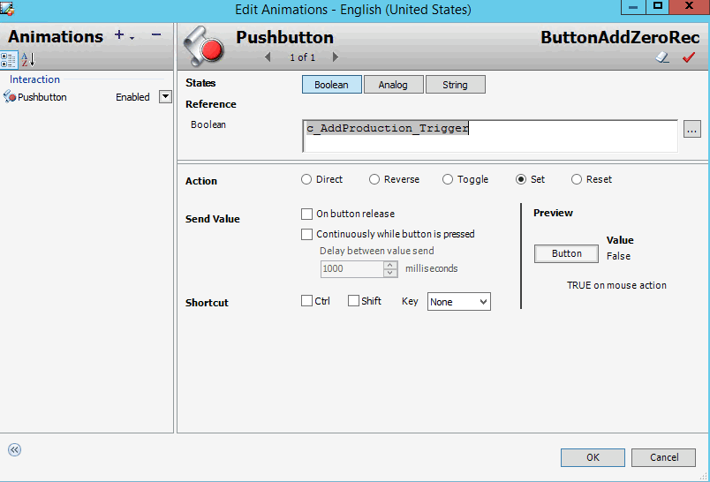

**[Script_AddProduction_Initialize]**

*''''''''''''''''''''''''''''''''''''''''''''''''''''''''''''''''''''''''''''*

*''''''''*

*' Script Name: Script_AddProduction_Initialize*

*' Expression: c_AddProduction_Trigger*

*' Trigger: OnTrue*

*'===================================================================================*

*' Author: Taki Guan <taki.guan@colpal.com>*

*' Creation Date: 2019-3-28*

*' Description: Initialize LineSelect Box and Shift Select Box*

*' Pre-condition:*

*' Post-condition:*

*'-----------------------------------------------------------------------------------*

*' Revision History:*

*' 000 - 2019-03-28 - Taki Guan <taki.guan@colpal.com>*

*' Initial Creation*

*''''''''''''''''''''''''''''''''''''''''''''''''''''''''''''''''''''''''''''''''''''*

c_AddProduction_Trigger = false;

grpProdRecon.Visible = false;

grpProdRecon_Injection.Visible = false;

grpProdRecon_Packaging.Visible = false;

b_AddProductionVisble = true;

*'Initialize LineSelectBox*

dim xmlBuilder As Fact.Common.XMLReadBuilder;

dim Result As aaFactMES.Result;

dim dataSet As System.Data.DataSet;

dim row As System.Data.DataRow;

dim clientSession As aaFactMES.aaClientSession;

dim messageText as string;

dim doc as System.Xml.XmlDocument;

dim msgNode as System.Xml.XmlNode;

dim displayString as string;

doc = new System.Xml.XmlDocument();

doc.Load(MyPlatform.Cfg.DictionaryFilePath);

result = aaFactMES.aaClientSession.GetInstance();

clientSession = result.Value;

*'Lookup the line information*

xmlBuilder = Fact.Common.XMLReadBuilder("OPERA_GetEntsByType", "GetByKey");

xmlBuilder.AddFilter("entity_type", "Line");

result = clientSession.GetDS(xmlBuilder.Xml);

if Result.Success then

    dataSet = result.Value;

    grpAddProduction.LineSelectBox.Items.Clear();

    grpAddProduction.LineSelectBox.Items.Add("");

    For Each row in dataSet.Tables(0).Rows

        grpAddProduction.LineSelectBox.Items.Add(row.Item("ent_name"));

    Next;

else

    msgNode = doc.SelectSingleNode("OPERA_Messages/ScreenName[@Name='operaAdmin_ProductionReconcile']/ErrorMessages/Message[@Name='Initialize_Fail']/Language[@ID='" + InTouch:$Language + "']");

    messageText = msgNode.InnerText + Result.Exception.Message.ToString();

    LogMessage(messageText);

    System.Windows.Forms.MessageBox.Show(messageText, "Initialization Failure", System.Windows.Forms.MessageBoxButtons.OK, System.Windows.Forms.MessageBoxIcon.Error);

endif;

*'Initialize date time picker*

grpAddProduction.AddProDateTimePicker.Value = System.DateTime.Now.Date;

*'Initialize ShiftSelectBox*

grpAddProduction.ShiftSelectBox.Items.Clear();

grpAddProduction.ShiftSelectBox.Items.Add("Shift1");

grpAddProduction.ShiftSelectBox.Items.Add("Shift2");

grpAddProduction.ShiftSelectBox.Items.Add("Shift3");

**[Script_AddProduction_Submit]**

*'''''''''''''''''''''''''''''''''''''''''''''''''''''''''''''''''''''''''''''''''''*

*' Script Name: Script_AddProduction_Submit*

*' Expression: c_AddProduction_Submit*

*' Trigger: OnTrue*

*'===================================================================================*

*' Author: Taki Guan <taki.guan@colpal.com>*

*' Creation Date: 2019-3-28*

*' Description: The update and selection logic after submit button clicked*

*' Pre-condition:*

*' Post-condition:*

*'-----------------------------------------------------------------------------------*

*' Revision History:*

*' 000 - 2019-03-28 - Taki Guan <taki.guan@colpal.com>*

*' Initial Creation*

*' 001 - 2019-04-01 - Taki Guan <taki.guan@colpal.com>*

*' If succesful then close the button*

*''''''''''''''''''''''''''''''''''''''''''''''''''''''''''''''''''''''''''''''''''''*

c_AddProduction_Submit = false;

*' Variable Definition*

dim result as aaFactMES.Result;

dim clientSession as aaFactMES.aaClientSession;

dim sqlQuery as string;

*' lineEntName and eqEntName is for query*

dim ent_name as string;

dim lineEntName as string;

dim eqEntName as string;

dim wo_id as string;

dim date as time;

dim queryDate as time;

dim shift as string;

dim user_id as string;

ent_name = grpAddProduction.LineSelectBox.Text;

wo_id = grpAddProduction.WOSelectBox.Text;

date = grpAddProduction.AddProDateTimePicker.Value;

shift = grpAddProduction.ShiftSelectBox.Text;

user_id = InTouch:MES_Cur_User;

*' set lineEntName and eqEntName base on differenct line type*

if ent_name.StartsWith("H2FCS") then

    lineEntName = ent_name;

    eqEntName = ent_name + "_FCS";

elseif ent_name.StartsWith("T2BH") then

    lineEntName = ent_name;

    eqEntName = ent_name + "_END";

elseif ent_name.StartsWith("P2HA") then

    lineEntName = ent_name;

    eqEntName = ent_name + "_HoongA";

endif;

*' queryDate is a comnination of date and shift*

if shift == "Shift1" then

    queryDate = date;

elseif shift == "Shift2" then

    queryDate = date.AddHours(8);

elseif shift == "Shift3" then

    queryDate = date.AddHours(16);

endif;

try

*' Collect local session data*

    result = aaFactMES.aaClientSession.GetInstance();

    clientSession = result.Value;

*' Start session if it doesn't exist*

    if clientSession.SessionId == -1 then

        clientSession.StartSession(aaFactMES.aaClientTypes.clientOperator);

    endif;

    if clientSession.SessionId <> -1 then

        sqlQuery = System.String.Format("sp_I_OPERA_AddZeroRecord '{0}','{1}','{2}','{3}','{4}'", user_id, queryDate, lineEntName, eqEntName, wo_id);

        LogMessage("sqlQuery: " + sqlQuery);

*' Retrieve DataSet using MES API*

        result = clientSession.GetDSbySQL(sqlQuery);

        if result.Success then

            LogMessage("Add Zero Count Successful!");

            ngsfrErrorDisplay1.Message = "Add Zero Count Successful!";

            ngsfrErrorDisplay1.Failure = false;

*' Set Visible to false*

            b_AddProductionVisble = false;

            if LineType == "Injection" then

                grpProdRecon_Injection.Visible = true;

                grpProdRecon_Packaging.Visible = false;

                grpProdRecon.Visible = false;

            elseif LineType == "Packaging" then

                grpProdRecon_Packaging.Visible = true;

                grpProdRecon_Injection.Visible = false;

                grpProdRecon.Visible = false;

            else

                grpProdRecon.Visible = True;

                grpProdRecon_Packaging.Visible = false;

                grpProdRecon_Injection.Visible = false;

            endif;

        else

            LogError("Add Zero Count Error: " + result.Exception.Message);

            ngsfrErrorDisplay1.Message = "Add Zero Count Failed!";

            ngsfrErrorDisplay1.Failure = true;

        endif;

    endif;

catch

endtry;

Then I need to add a store procedure to MESDB. Execute current script to add below store procedure.

**[sp_I_OPERA_AddZeroRecord]**

Below attributes are transfer to this store procedure to execute.

|  |  |
| --- | --- |
| @userID | OPERA User |
| @shiftTime | Date time to add record |
| @lineEntName | Line name to add record |
| @equEntName | Equipment name to add record |
| @woID | Work Order ID |

USE [MESDB]

GO

*/****** Object: StoredProcedure [dbo].[sp_I_OPERA_AddZeroRecord] Script Date: 2019/4/2 11:31:21 ******/*

SET ANSI_NULLS ON

GO

SET QUOTED_IDENTIFIER ON

GO

*-- \*\*\*\*\*\*\*\*\*\*\*\*\*\*\*\*\*\*\*\*\*\*\*\*\*\*\*\*\*\*\*\*\*\*\*\*\*\*\*\*\*\*\*\*\*\*\*\*\*\*\*\*\*\*\*\*\*\*\*\*\*\*\*\*\*\*\*\*\*\*\*\*\*\*\*\*\*\*\*\*\*\*\*\*\*\*\*\*\*\*\*\*\*\*\*\*\*\*\*\*\*\*\*\*\*\*\*\*\*\*\*\*\*\*\*\*\*\*\**

*-- Module Name          - sp_I_OPERA_AddZeroRecord*

*-- Description          -   Add Zero Record*

*-- Author               -   Taki Guan*

*-- Date Created         -   2019/3/29*

*-- Version              - 0.0.0*

*--*

*-- Copyright (C) 2019 Colgate Sanxiao Inc. All rights reserved.*

*--*

*-- THIS CODE AND INFORMATION ARE PROVIDED "AS IS" WITHOUT WARRANTY OF ANY*

*-- KIND, EITHER EXPRESSED OR IMPLIED, INCLUDING BUT NOT LIMITED TO THE*

*-- IMPLIED WARRANTIES OF MERCHANTABILITY AND/OR FITNESS FOR A*

*-- PARTICULAR PURPOSE.*

*----------------------------------------------------------------------------------------------------------------------------*

*-- Date_Modified    Modified_By     Ver         Changes*

*-- 2019/3/29        Taki Guan       0.0.0       Initial Creation*

*--*

*----------------------------------------------------------------------------------------------------------------------------*

*-- \*\*\*\*\*\*\*\*\*\*\*\*\*\*\*\*\*\*\*\*\*\*\*\*\*\*\*\*\*\*\*\*\*\*\*\*\*\*\*\*\*\*\*\*\*\*\*\*\*\*\*\*\*\*\*\*\*\*\*\*\*\*\*\*\*\*\*\*\*\*\*\*\*\*\*\*\*\*\*\*\*\*\*\*\*\*\*\*\*\*\*\*\*\*\*\*\*\*\*\*\*\*\*\*\*\*\*\*\*\*\*\*\*\*\*\*\*\*\*\*\**

CREATE PROCEDURE [dbo].[sp_I_OPERA_AddZeroRecord]

(

    @userID AS nvarchar(40),

    @shiftTime AS datetime,

    @lineEntName AS nvarchar(40),

    @equEntName AS nvarchar(40),

    @woID AS nvarchar(40)

)

AS

BEGIN

    BEGIN TRANSACTION;

    declare @sessID int,@lineEntID int,@eqEntId int,@itemID nvarchar(40),@seqNO int,@qty float,@operID nvarchar(20),@shiftID int

    select top 1 @sessID=session_id from sessn where std_time=0

*-- set @userID='MF\Taki Guan'*

*-- set @lineEntID=187*

*-- set @eqEntId=190*

*-- select top 1 @lineEntID=ent_id from ent where ent_name='H2FCS904'*

*-- select top 1 @eqEntId=ent_id from ent where ent_name='H2FCS904_FCS'*

    select top 1 @lineEntID=ent_id from ent where ent_name=@lineEntName

    select top 1 @eqEntId=ent_id from ent where ent_name= @equEntName

*-- select top 1 @lineEntID=ent_id from ent where ent_name='P2HA6015'*

*-- select top 1 @eqEntId=ent_id from ent where ent_name='P2HA6015_HoongA'*

*-- set @woID='000' + '102094897'*

*-- set @woID= '000102087677'*

*-- set @shiftTime='2019-03-26 16:00:00'*

    set @qty=0

    select top 1 @itemID=item_id from wo where wo_id=@woID

    if @itemID is not null

    begin

        select top 1 @seqNO=seq_no,@operID=oper_id

        from job where wo_id=@woID and target_sched_ent_id=@eqEntId order by seq_no desc

*--*

        declare @lineProdRate float,@eqProdRate float

        declare @varQtyReqd float,@varBatchSize float,@varProdUom int

        set @lineProdRate=dbo.fn_GetProdRate(@lineEntID,@itemID)

        set @eqProdRate=dbo.fn_GetProdRate(@eqEntId,@itemID)

        select top 1 @varQtyReqd=qty_reqd,@varProdUom=prod_uom from job where wo_id=@woID and seq_no=0

        update job set batch_size=@lineProdRate where wo_id=@woID and seq_no=0

*--*

        if @seqNO is null

        begin

            select top 1 @seqNO=max(seq_no) from job where wo_id=@woID

            if @seqNO is not null

            begin

                set @seqNO=@seqNO+1

                set @operID='10'

                set @varQtyReqd=round(@varQtyReqd*@eqProdRate*1.0/@lineProdRate,2)

                set @varBatchSize=round(@eqProdRate,2)

                exec sp_i_job @woID,@operID,@seqNO,@operID,@itemID,2,1,null,null,@eqEntId,@eqEntId,@eqEntId,@varQtyReqd,0,0,0,0,@varQtyReqd,-0.01,1,@varBatchSize,0,0,0,0,null,null,null,null,1,@varProdUom,null,null,null,null,null,null,null,null,null,null,null,0,null,0,0,null,null,null,null,@seqNO,null,0,null,null,null,null,null,null,null,null,1,null

            end

        end

        if @seqNO is not null and @seqNO>0

        begin

            select top 1 @shiftID=shift_id

            from shift_history where shift_start_local<=@shiftTime and shift_end_local>@shiftTime

            update job set act_start_time_local=isnull(act_start_time_local,getdate()),

                state_cd =case when state_cd<4 then 4 else state_cd end,

                run_ent_id=ISNULL(run_ent_id,target_sched_ent_id)

            where wo_id=@woID

            exec sp_I_Item_Prod_AddProdPostExecExt @sessID,@userID,@eqEntId,@qty,@woID,@operID,@seqNO,@shiftTime,@shiftTime,@shiftID,@itemID,2

            exec sp_I_Item_Prod_AddProdPostExecExt @sessID,@userID,@lineEntID,@qty,@woID,@operID,0,@shiftTime,@shiftTime,@shiftID,@itemID,2

        end

    end

COMMIT TRANSACTION;

END;

GO

# Reference Link